Puzzle Force

# Gameplay Overview

Take control of a spaceship in this mash-up of Space Invaders and Puzzle games. Clear lines of enemies just like in popular games such as Candy Crush Saga and Bejeweled while getting all the old-school arcade action of games like Space Invaders and Galaga.

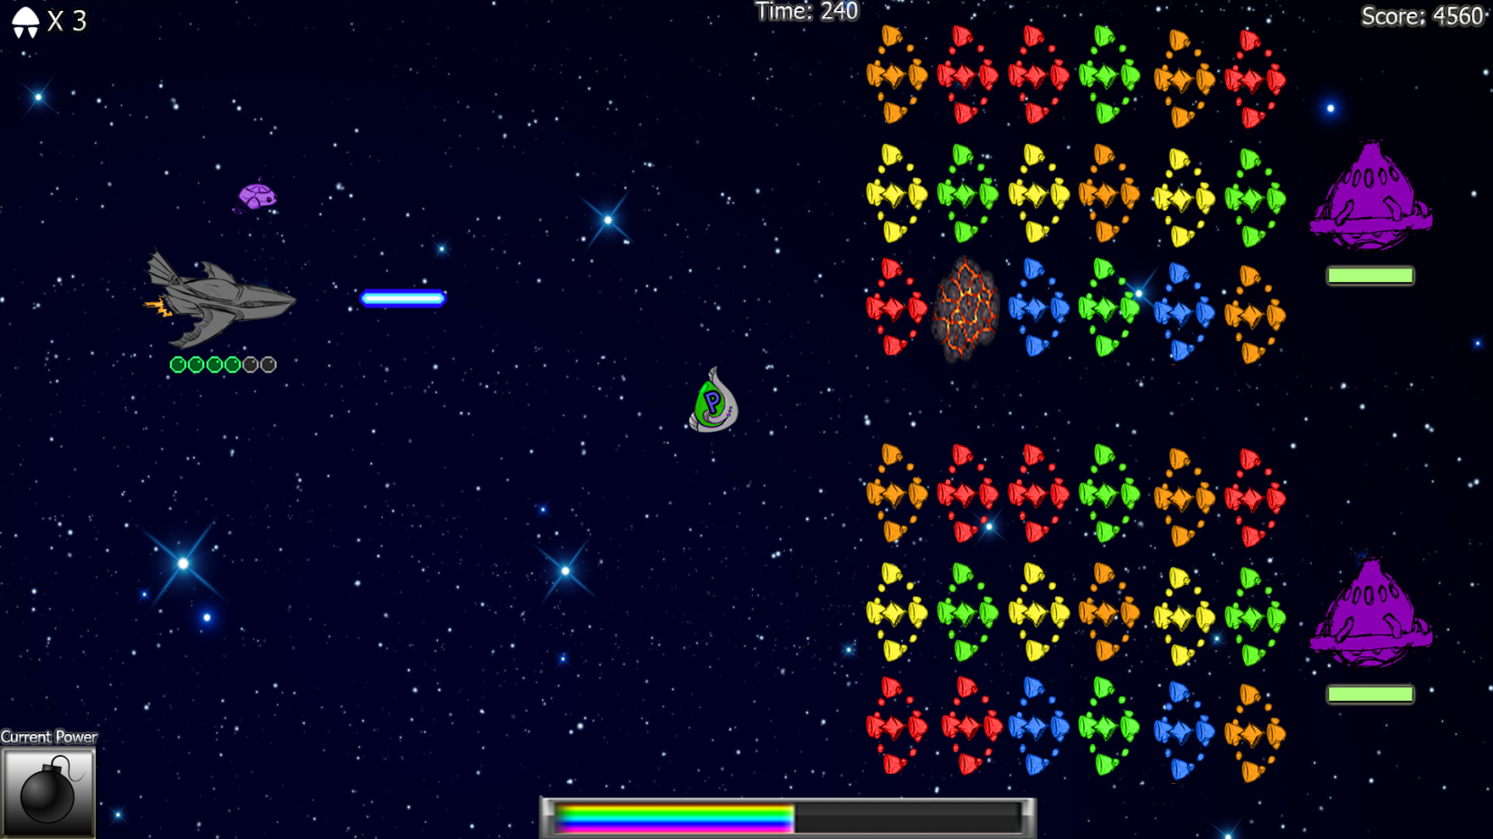

*UI Mock-up (version 3.0)*

## Expanded Gameplay

Players will take control of a spaceship a la “Galaga”, firing at rows of enemies in clusters that come down from the top of the screen while avoiding static obstacles and level hazards. Enemies fire back but are also part of the puzzle game board. The objective is to clear the target amount of enemies to move on to the next cluster. Clearing faster with larger combinations will yield better scores. To clear enemies, players will have to shoot different-colored enemies to form three of a kind color combinations. Shooting enemies normally won’t technically destroy them. Instead, enemies shot will be moved to the back of the line they were in, pushing the enemy that was behind it forward. Clearing enemies via a line of 3 or more will reduce the health of the mothership for an individual cluster. Once the health of the mothership of that cluster is depleted, the cluster will explod, a new one will replace it with a new mothership, and this will repeat until all the objectives of the level are complete or a boss battle begins.

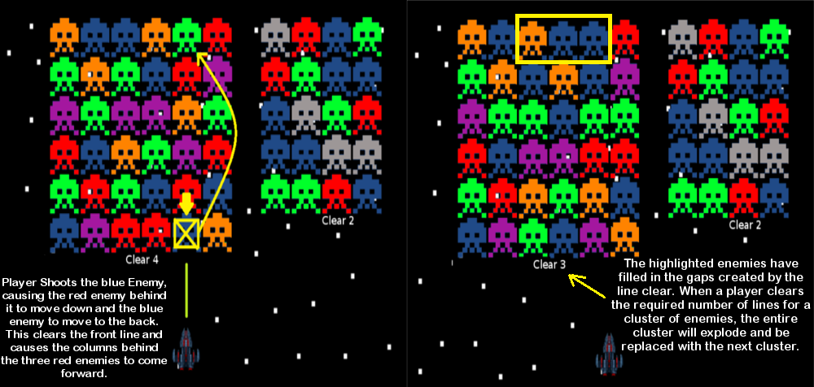

Players can also build up a “Frenzy Meter” by matching combos quickly or making combos of more than three. When the Frenzy Meter is full, the game goes into Frenzy Mode. This will rapidly throw clusters of enemies at the player that only one shot needs to be made to clear the entire cluster, giving the player a huge score bonus. This continues until the Frenzy Meter drains back to zero.

Better performances earn the player more coins to spend on power-ups. Players can equip three power-ups before each level. Equipping them will prompt them to show up in enemy clusters for activation. Equipping a power-up uses up one of its uses until you have none of that specific power-up left. In this situation, players must use the coins they’ve acquired from playing to purchase power-up uses or new power-ups. Players also receive a daily stipend of coins to make sure they’re never completely out of power-ups and out of the game.

## Controls

W+S for up and down movement. Left Mouse Button to fire. Right click to use power-up. Customizeable.

## Modes

Arcade Mode: Players must get through various levels, clearing enemies to advance. At the end of every 10 levels is a boss battle. The boss battles will all feature unique mechanics. The object of the game is to get to the end of all the levels before losing all of your lives. Players start with three lives and can earn more through playing well.

Endless Mode: Players compete to see the max score they can get and post their score on the worldwide high score table and their own, more personal,facebook friends high score table.

## Power-ups

To help the player get to the end of the game, they can utilize power-ups. Power-ups are acquired by clearing asteroids in a line clear. Asteroids will match with any three+ combination. Clearing it will release a power-up capsule that the player must collect by flying into it. The more capsules collected, the stronger the power-up when the player "cashes in". Players can customize their power-up loadouts to cater to specific play styles. For example, one power-up line will give the player a Super Laser when cashing in one power-up capsule while another line will give the player a movement speed boost for one capsule. There are 6 stages of power-ups available. The first three power-up slots are considered "simple power-ups" and players can only pick from a pool of simple power-ups to fill these slots. The last three slots are "advanced power-ups" and players can only pick from advanced power-ups for these slots. Below are some examples of simple and advanced power-ups.

**Super Laser:** Next normal attack clears an entire vertical line of enemies. Simple.

**Arc Laser:** Next normal attack clears all enemies of the same color as the first one shot. Advanced.

**Cluster Bomb:** Fires a cluster bomb that can be detonated by pressing the attack button again. Its explosion clears a 4x4 radius of enemies. Advanced.

**Shield:** Grants the player a shield they can place by hitting the fire button after acquiring. The shield will stay still after being placed. The shield is not destroyed by level obstacles/hazards. Enemy lasers, however, will eat away at the shield as it is hit. Players can fire through the shield themselves. Only one allowed at a time. Simple.

**Time Shift:** Slows down everything except for the player’s ship for 3 seconds to allow more time for thinking/dodging. Simple.

**Homing Missile:** Automatically arranges the current cluster for the highest possible score. Advanced.

**Frenzy Engine:** Build up frenzy meter faster for the next 15 seconds. Simple.

**Nova Bomb:** Clears entire board instantly. Does massive damage to bosses. Advanced. Sixth slot only.

## Enemy Types

Various enemy types will challenge the player as the game progresses.

**Basic Aliens:** These aliens will fire very slowly if they’re on the very front line. Used to complete most clears.

**Mother Ship**: The "leader" of each cluster, this ship has ranging amounts of health that will need to be depleted to clear a cluster. There will be a variety of motherships, each with their own flavor of challenge. Some motherships will convert basic alien ships into one of the types listed below. Others will prompt individual ships to come in and dive-bomb the player's ship or make the basic ships fire much faster than usual.

**Shielded Alien:** Needs to have a combination cleared immediately next to it to allow the player to clear this alien. Cannot be used into combinations until the shield is gone.

**Bomb Alien:** These bombs are colored various colors to make matches with. Players have 10 seconds to clear them early in the game and 5 seconds in later levels of the game. If the player fails to clear them out, the bomb explodes and will take a life away from the player.

**Chromatic Alien:** Can be used in any combination to clear. Counts as all colors at the same time.

**Heavy Armor Alien:** Cannot be cleared, does not move down the column when the leader of the column is shot.

**Gunner Alien:** Like a normal alien but fires much more rapidly at the alien when in the front line.

**Phasing Alien:** Every time a column is moved, this alien shifts between tangible and intangible. When intangible. The alien cannot be cleared.

**Obstacles/Static Objects:** As the player “flies” through a level, obstacles will come down like asteroids or laser sentries that will fire at the enemy as it drops. These must be dodged or shot. Breaking them requires a few shots with the normal fire from the player ship and provide a modest bonus. Players will sometimes encounter black holes. These will block shots at the column once it gets in front of it and will also suck the player in if they get too close.

## Scoring and Rewards System

3 alien clear (any color)- 50

4 alien clear (any color)- 100

5 alien clear (any color)- 500

2x match (any two colors at the same time)- +50 bonus to each clear’s value. Ex: 3 red clear + 3 blue clear + 50x2 = 200  
Cascade Clear- increments of +50 for each match beyond the initial match that started the chain reaction. Ex: 3 red clear causes a 3 blue clear which, in turn, causes a 3 green clear. (50 + 50) + (50 + 100) + (50 + 150)

Aliens cleared by power-ups- +50 for each alien cleared

Nova Bomb- +25 for each alien cleared. Clears any clusters on the screen.

Activating defensive power-ups- +150

Frenzy Mode- All previously listed bonuses are doubled during frenzy mode.

Players are awarded currency on a 100 points to 1 Medal exchange ratio. Medals can be used in the upgrade shop. Values are listed below (subject to change):

Tier 1 Power-up x3 = 200 medals

Tier 2 Power-up x3 = 300 medals

Tier 3 Power-up x3 = 400 medals

Permanent Single Tier 1 Unlock = 4000 medals

Permanent Single Tier 2 Unlock = 6000 medals

Permanent Single Tier 3 Unlock = 8000 medals

Permanent Bundle Tier 1 Unlock = 14000 Medals

## Reference Material

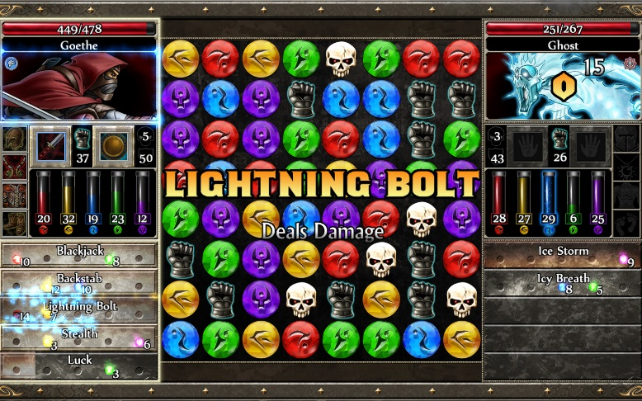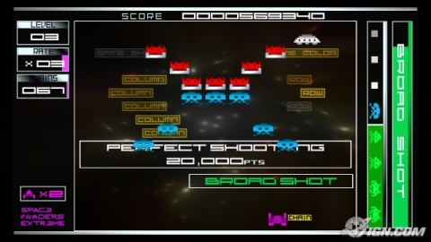

The match 3/4 gameplay style is adopted from games like Puzzle Quest or Candy Crush Saga. The Shoot ‘Em Up aspect is taken from games like Space Invaders Extreme or Galaga. Art style will be like Space Invaders Extreme.